VerSiFlow Power Cord installation
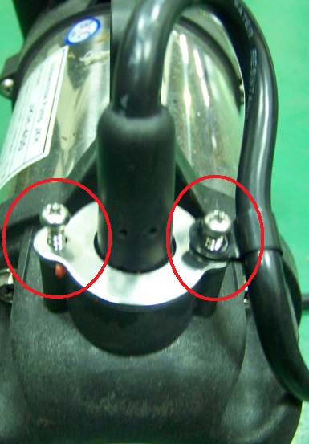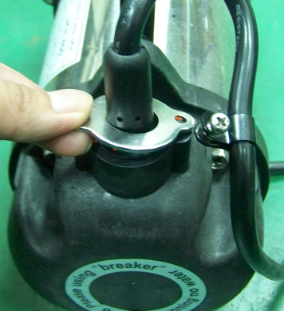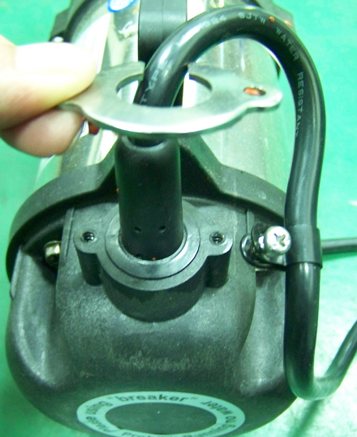
Unscrew and remove the metal bracket.
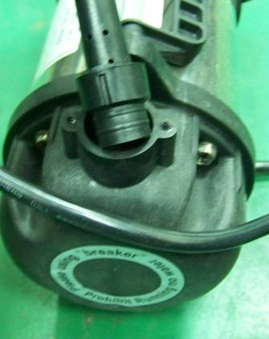 Pull out the power cord.
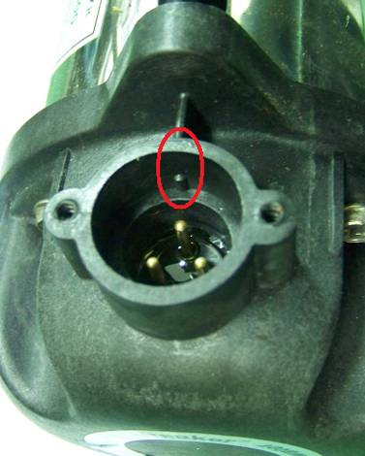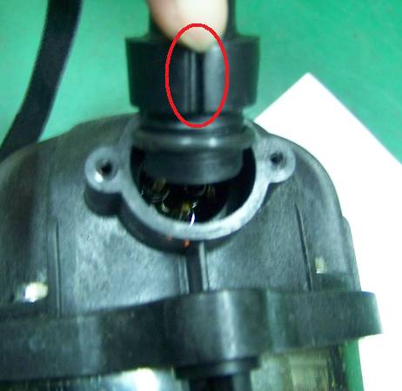
Before installing the new power cord, add a little silicone sealant to the area with the yellow arrow. Insert the new plug into the groove vertically. Be sure to align plug with the groove as shown in red circles.
Please note the corresponding install positions
Put the bracket back on.
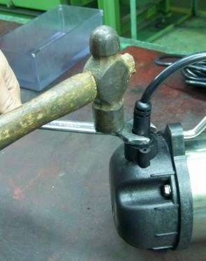
Put a wrench on the bracket, and use a hammer to tap the plug in to place (you need to push pretty hard to get the plug fully seated).
Screw the bracket to the cable end (screw Torque: 25 kgf＊cm).

Allow silicone to dry for six to twelve hours.

